The landscape constitutes a subject of scientific study uniting the specialists representing different fields of research, both geographers and biologists as well as architects and sociologists. A number of different methods are used in the research on the landscape. Also the interpretation of the landscape content and the approach to its shaping and protection can be conducted in many different ways.

The aim of the conference is to confront various schools researching the landscape, compare the methods used, exchange experience and search the ways of communication among different methodological orientations.

It is envisaged that the basis for further discussion will be both the commissioned papers given by speakers representing various research schools, and other talks and presentations concerning solutions adopted in different research centres. The conference proceedings, discussion and conclusions will be published in a separate volume.

Among the particular aims there are the following proposals:
- theory and its usage in practice
- interdisciplinary co-operation and development of the research on the landscape
- the type of landscape versus the research methods
- new research tools and their impact on the development of methodology of the analysis of the landscape

Fees
full participation cost – 150 Euro*
(IALE, PAEK and KKK members – 120 Euro)

* the fee covers: the reception, conference fee, proceedings, publishing monographic book, board (coffee brake and 2 lunch), a guided tour of Krynica

CONFERENCE ACCOUNT:

Polskie Towarzystwo Geograficzne
Oddział w Katowicach

41-200 Sosnowiec, ul Będzińska 60

BP PKO II Oddz. Katowice
67 1020 2313 0000 3102 0139 1168

Please, transfer the conference fee with
a note:
(METHODS OF THE LANDSCAPE RESEARCH) and the participant's name

Due to organizational reasons, the participants are asked to send their applications promptly to the address as given below:

dr Urszula Myga-Piątek dr Ewa Malinowska
41-200 Sosnowiec 00-927 Warszawa
ul. Będzińska 60 Krakowskie Przedmieście 30
ump@wnoz.us.edu.pl emal@uw.ed.pl

tel. 32 3689 361 tel. 22 552 07 55

ORGANIZATIONAL COMMITTEE

- Chair:
Dr Urszula Myga-Piątek
- Vice-chair:
Dr Ewa Malinowska
- Secretary:
Dr Grzegorz Jankowski
- Treasurer
Mgr Andrzej Soczówka
- Secretary office:
Mgr Partycja Dzikowska
Mgr Piotr Hermanowski

SCIENTIFIC COMMITTEE

- Prof. dr hab. Andrzej Richling
- Prof. dr hab. Jacek Jania
- Prof. dr hab. Wiaczesław Andrejczuk

DEADLINES:

- The deadline for applications is
31. October 2007.
- The deadline for sending Abstracts:
31 October 2007.
- II Announcement to the participants:
15 November 2007.
- The deadline for sending the Conference fee – 150 euro – 30 November 2007.
- The deadline for sending full text to publishing in monograph – 5 March 2008

REGISTRATION FORM FOR THE INTERNATIONAL CONFERENCE
METHODS OF THE LANDSCAPE RESEARCH
3-5 march 2008 in Krynica
First name
Surname
Scientific degree
University or other institution's name

NIP and the university or other institution's address – to issue an invoice (to be refunded the conference fee, accommodation and catering)

I declare a paper to be presented at the conference |  | yes/no)
Title:

I declare readiness to take part in a discussion (5 min.) on .........

I declare readiness to present a selected problem during a study tour (the scope of research and localisation should be specified)

I declare to submit a poster entitled:

(underline the appropriate – specify the number, title and format)
The participant's address (for correspondence), tel. number, e-mail
The participant's signature |  |  | 

Conference Centre
GEOVITA – Krynica, Leśna street.

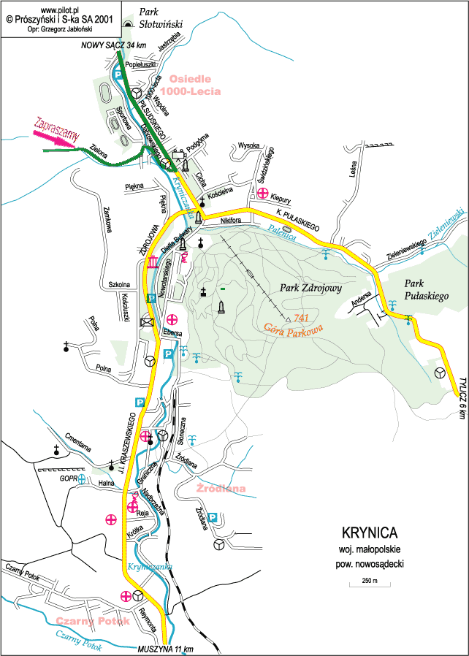

Committee of Cultural Landscape of Polish Geographical Society,

Polish Association of Landscape Ecology,

Faculty of Geography and Regional Studies of the Warsaw University

And

Faculty of Earth Sciences of the Silesian University

welcome to join the International Scientific Conference:

METHODS OF THE LANDSCAPE RESEARCH

which will take place
in 3-5 March 2008

in Krynica (Carpathian)

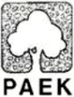
WYDZIAŁ GEOGRAFII
I STUDIÓW REGIONALNYCH

WYDZIAŁ NAUK O ZIEMI



